SME CYBERSECURITY RISK ASSESSMENT REPORT

- Introduction:
Small and medium-sized businesses rely on digital systems for communication, transactions and storing business information. This creates risks such as phishing, ransomware, unauthorized access, insider threats and data breaches.

This project applies a simple cybersecurity risk-assessment approach based on the NIST Cybersecurity Framework (CSF) 2.0 to identify, evaluate and reduce cybersecurity risks.

- Objectives:
- Identify common cybersecurity risks affecting SMEs.
- Create a risk register and risk matrix.
- Calculate and prioritize risks using likelihood and impact.
- Recommend suitable mitigation measures.
- Evaluate residual risk after mitigation.
- Apply the framework to two business case studies.

- Identified Cybersecurity Risks:

Risk ID | Threat | Likelihood | Impact | Risk Score | Risk Level
R001 | Phishing | 4 | 5 | 20 | Critical
R002 | Ransomware | 4 | 5 | 20 | Critical
R003 | Insider Threat | 3 | 4 | 12 | High
R004 | Unauthorized Access | 3 | 4 | 12 | High
R005 | Data Breach | 3 | 5 | 15 | High

These risks were selected as representative cybersecurity threats affecting SME systems, accounts and information.

- Risk Assessment Framework:
- NIST CSF 2.0:
The project uses the NIST Cybersecurity Framework (CSF) 2.0 to structure the risk assessment.
The six NIST CSF Functions are:
- Govern
- Identify
- Protect
- Detect
- Respond
- Recover
The risks in this project are mainly mapped to the Protect Function because the recommended controls focus on reducing cybersecurity risk.
- Risk Register:

The Risk Register records:

- Risk ID
- Asset and business area
- Threat and vulnerability
- Existing controls
- Likelihood and impact
- Risk score and level
- Recommended mitigation
- NIST CSF Function
- Residual risk

- Risk Matrix:
A 5×5 risk matrix was created using likelihood and impact to classify risks as Low, Moderate, High or Critical.

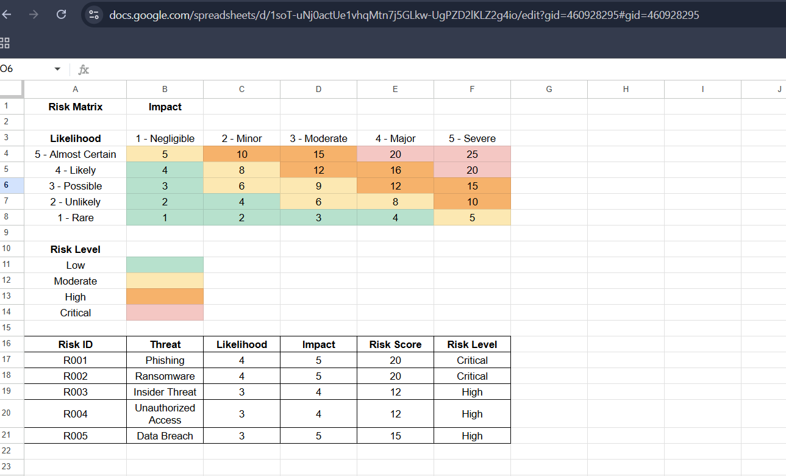

- Risk Evaluation:

Risk Score
Risk Score = Likelihood × Impact

Risk Level | Risk Score
Low | 1 – 4
Moderate | 5 – 9
High | 10 – 15
Critical | 16 – 25

The score helps prioritize risks according to their severity.

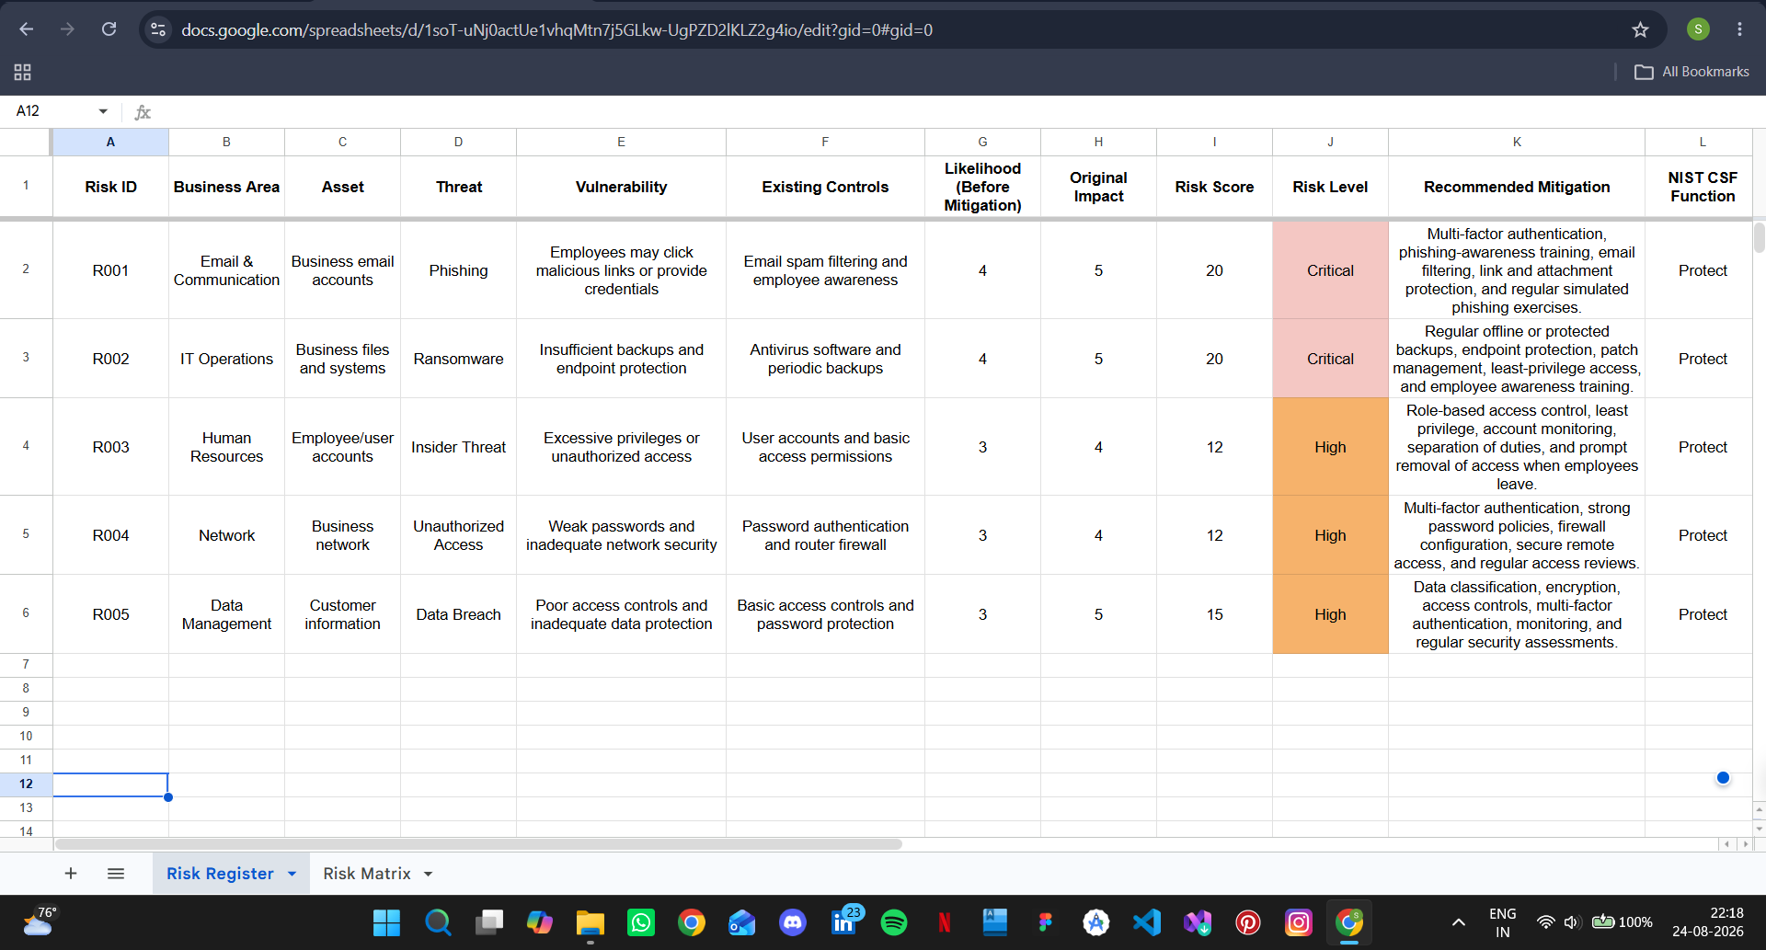

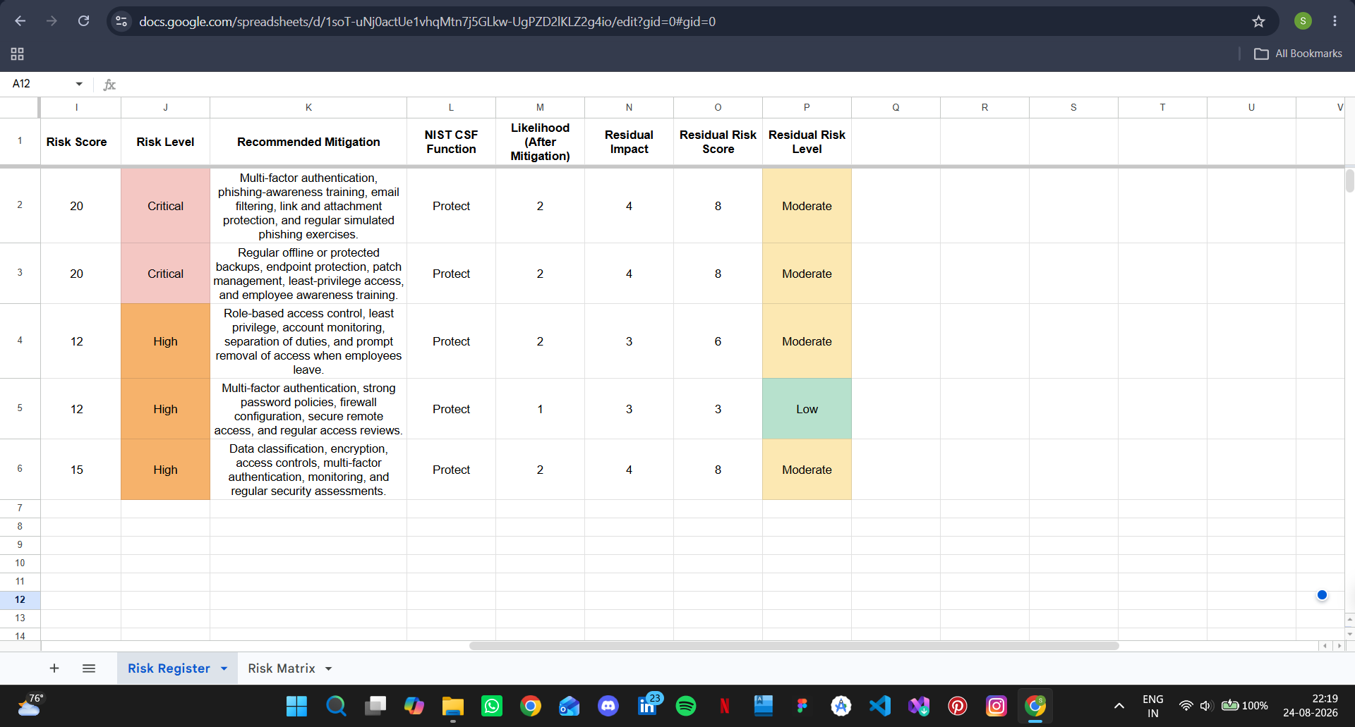

- Risk Mitigation:

Recommended controls included:

Risk | Main Mitigation
Phishing | MFA, awareness training, email filtering
Ransomware | Protected backups, endpoint protection, patching
Insider Threat | RBAC, least privilege, access reviews
Unauthorized Access | MFA, strong passwords, secure remote access
Data Breach | Encryption, access controls, monitoring

These controls are mainly mapped to the NIST CSF Protect Function.

- Residual Risk:

Risk ID | Initial | Residual | Final Level
R001 | 20 Critical | 8 | Moderate
R002 | 20 Critical | 8 | Moderate
R003 | 12 High | 6 | Moderate
R004 | 12 High | 3 | Low
R005 | 15 High | 8 | Moderate
The results show that the proposed controls reduce the overall risk, although some residual risk remains.



  - Case Studies:

- Retail/E-Commerce Business:
The first case study assessed a small retail/e-commerce business using email, online payments, computers and digital storage. The main risks were phishing, ransomware and data breach.

The highest initial risk was 20 – Critical. After mitigation, the risks were reduced to 8 – Moderate.

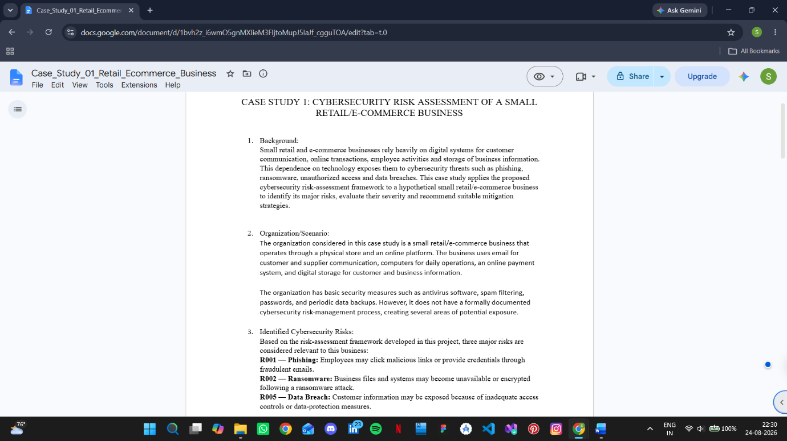

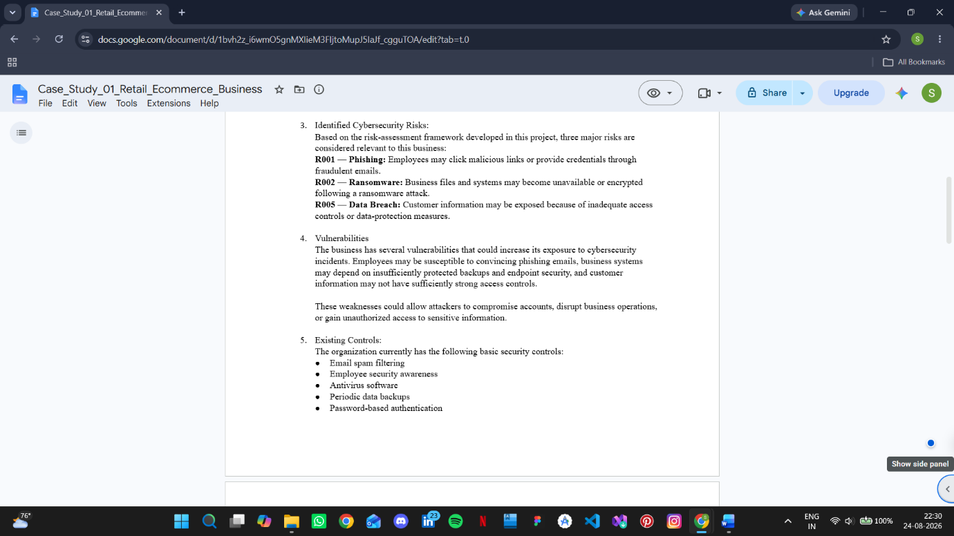

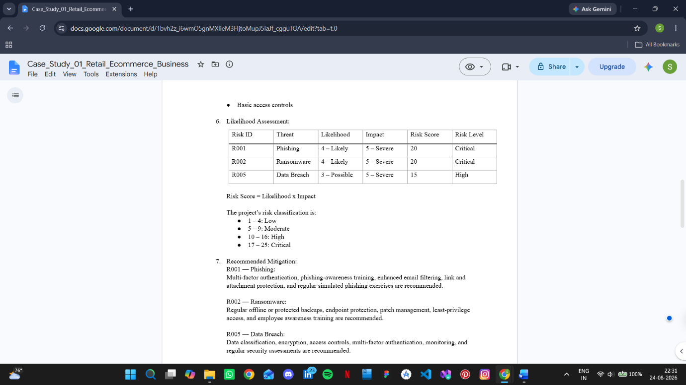

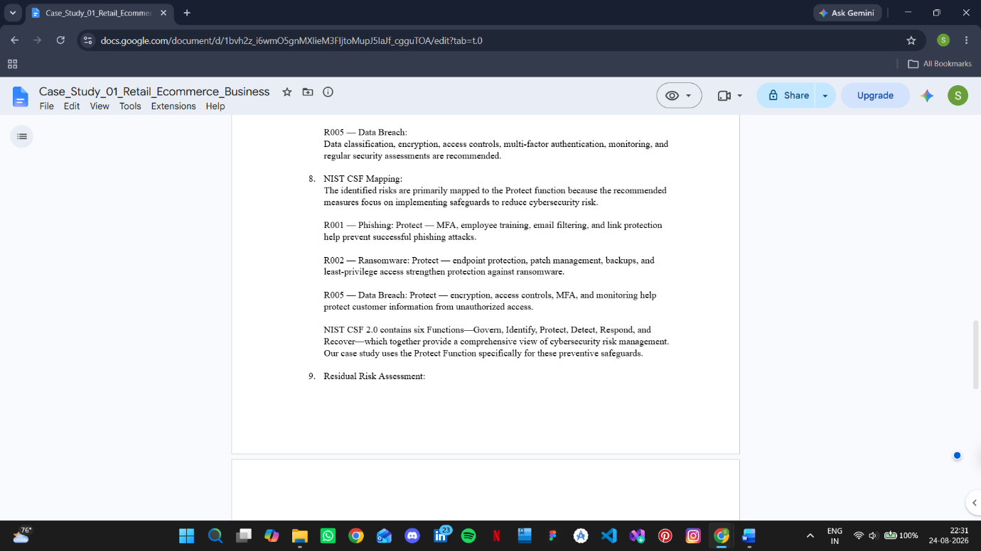

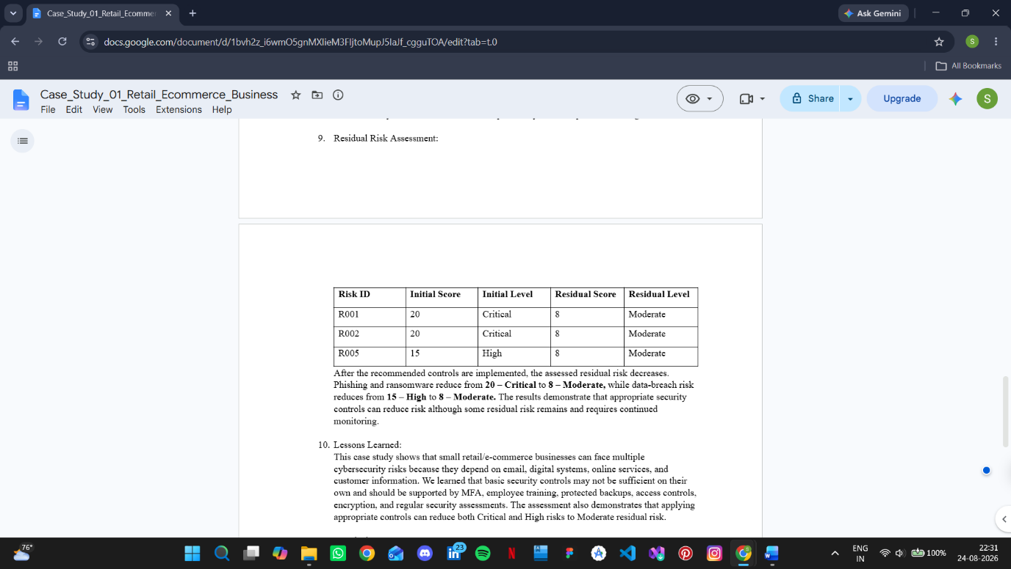
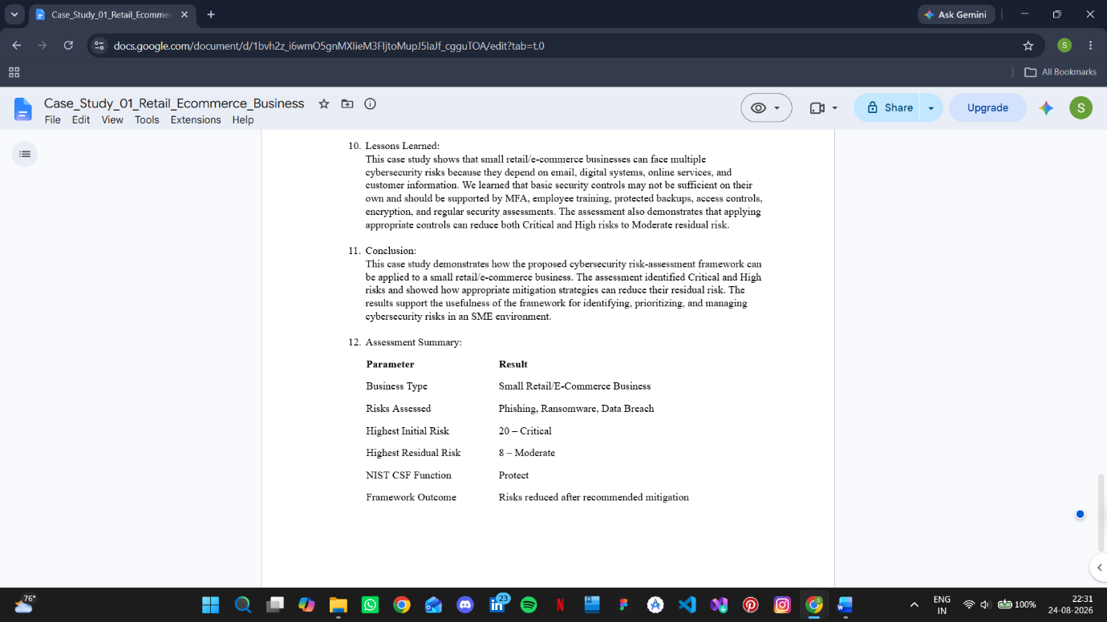

- 8.2 Professional Services Business:

The second case study assessed a small professional services business using email, cloud storage, computers and employee accounts. The main risks were phishing, insider threat and unauthorized access.

After mitigation, phishing reduced from 20 Critical to 8 Moderate, insider threat from 12 High to 6 Moderate, and unauthorized access from 12 High to 3 Low.

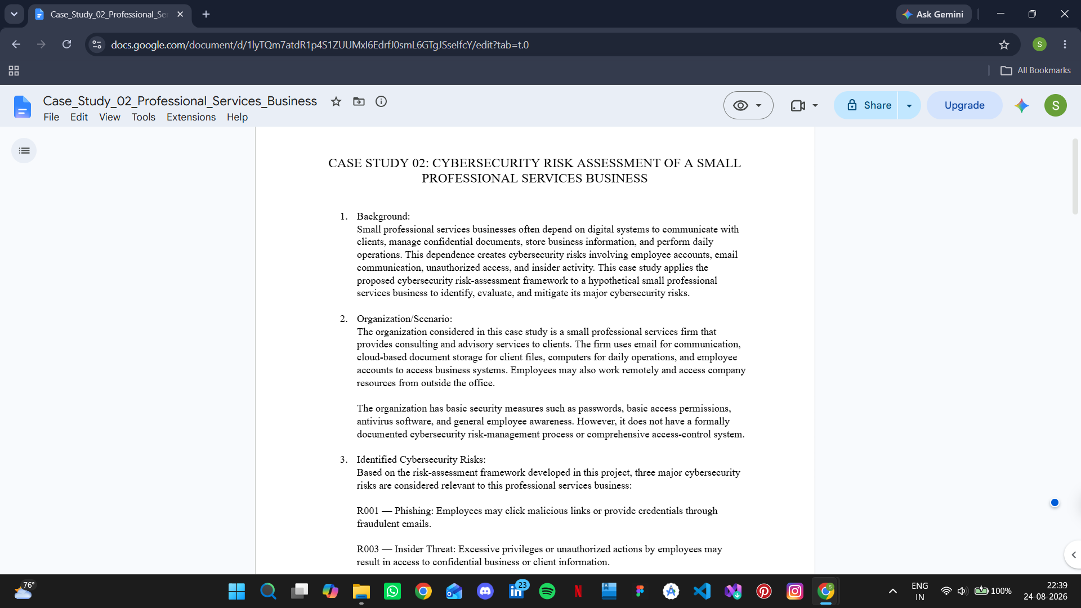

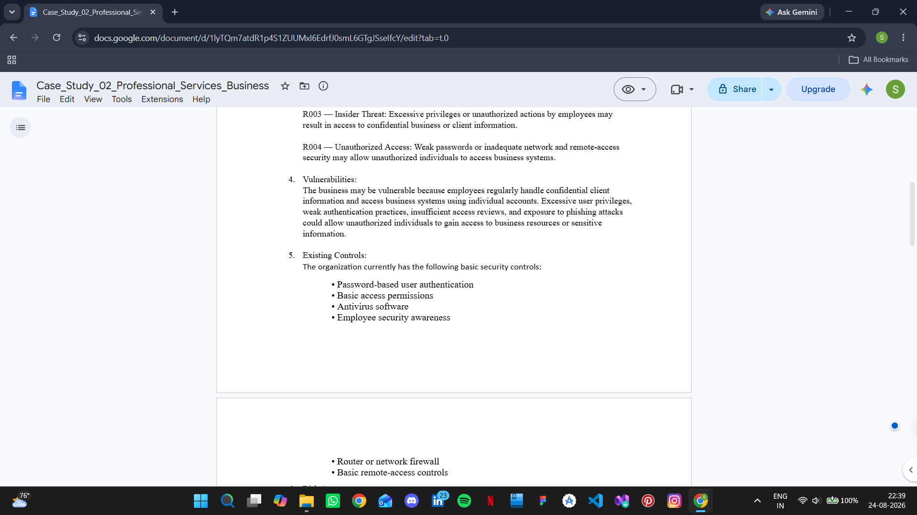
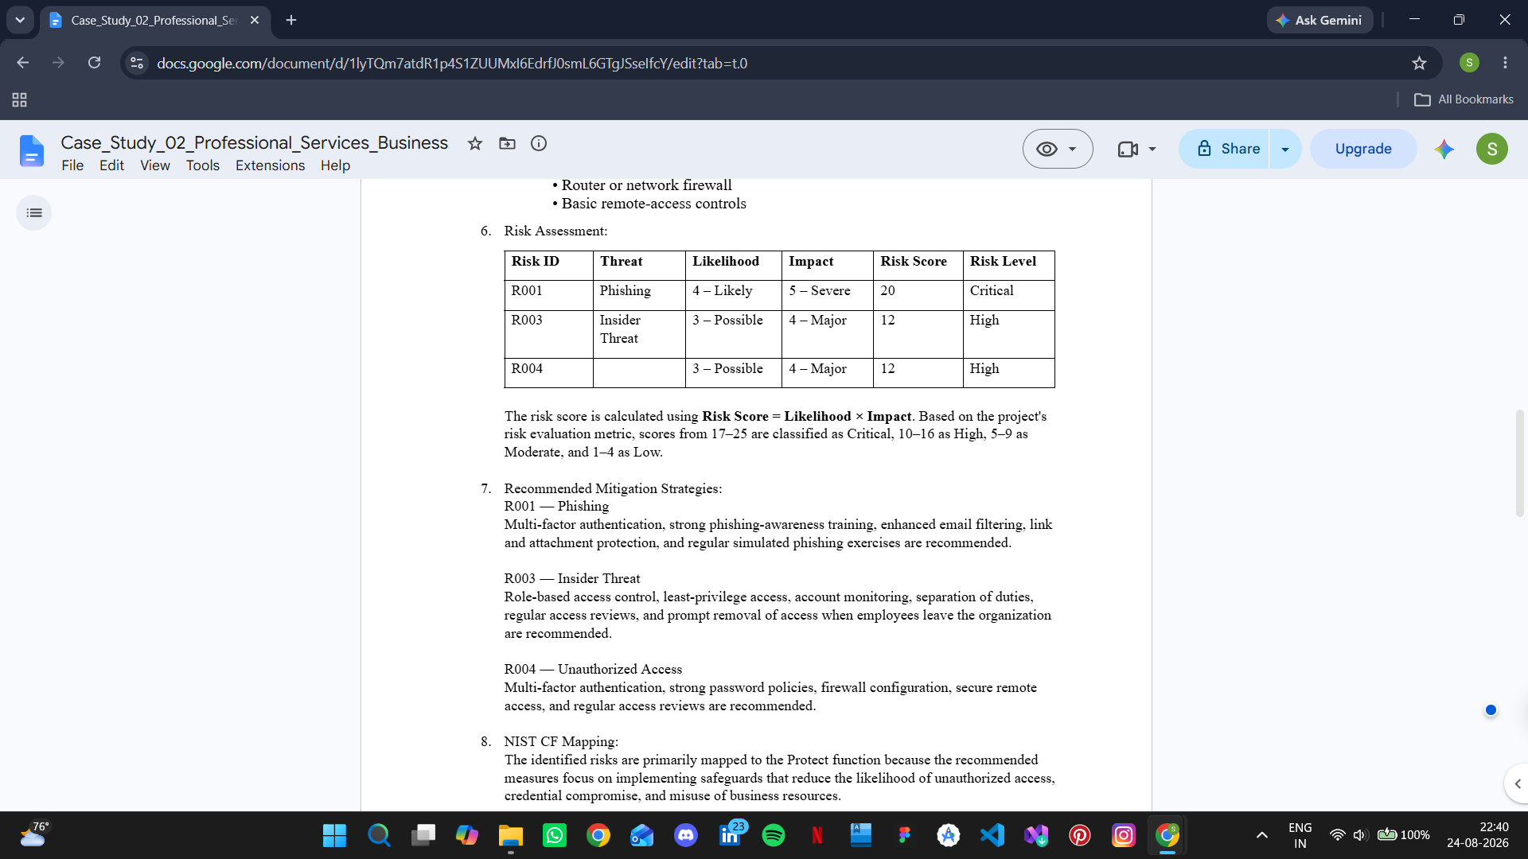

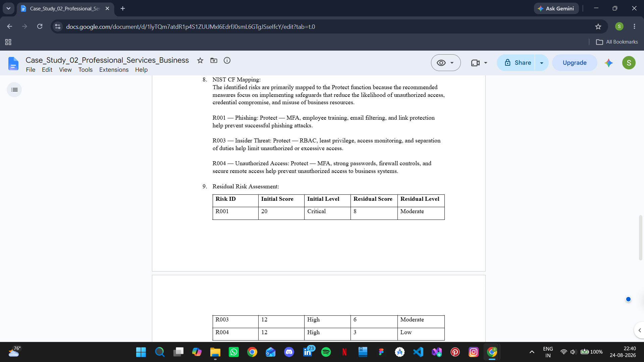
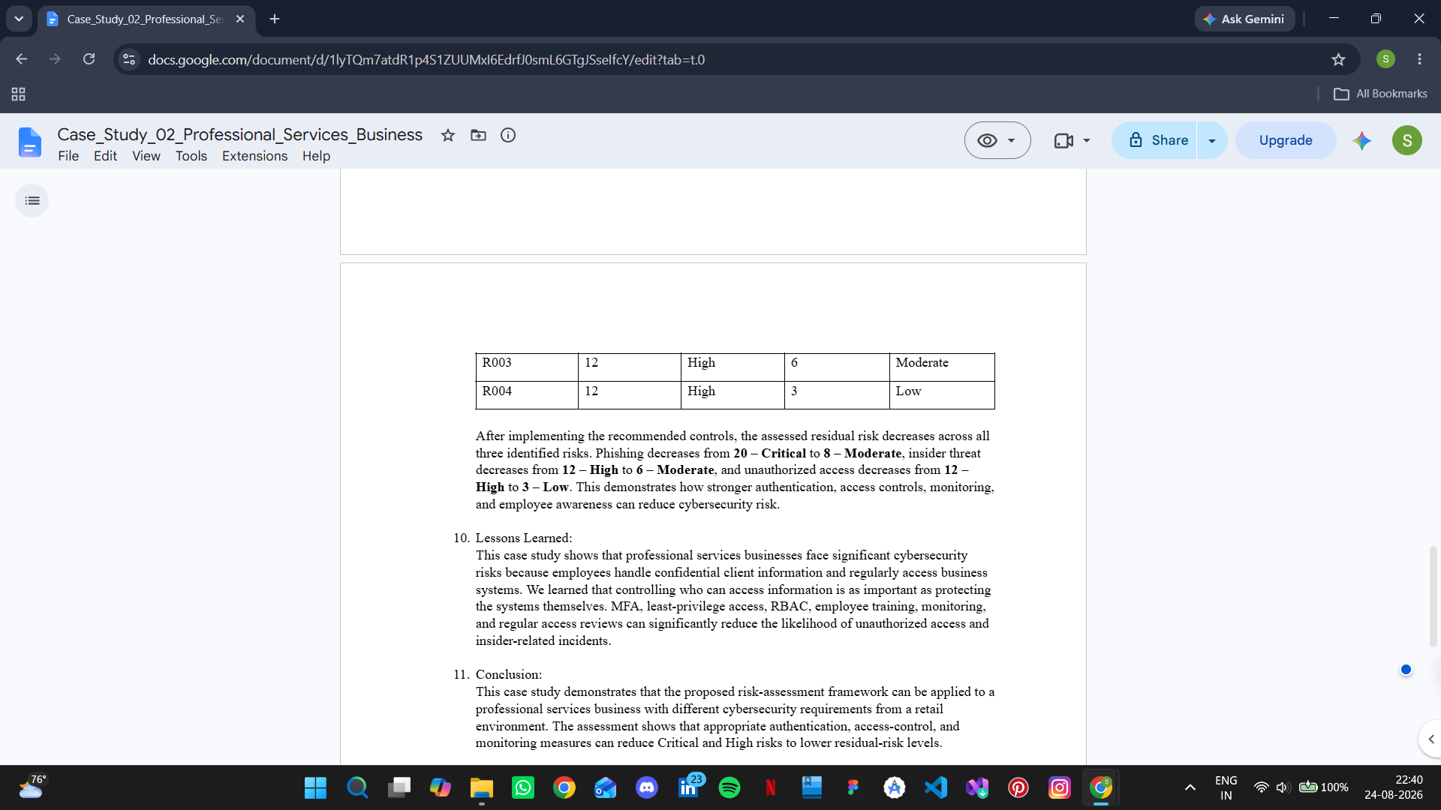

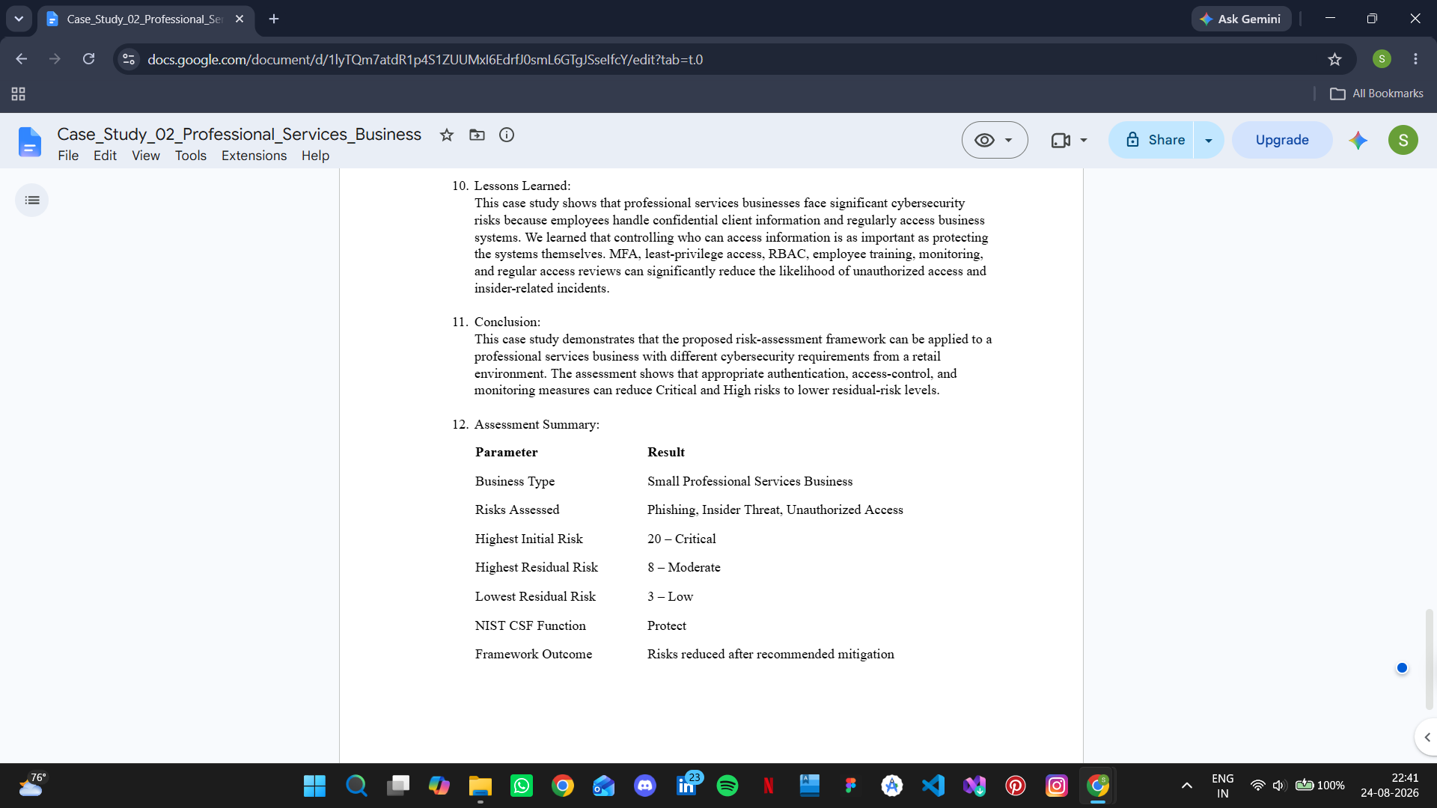

- Lessons Learned:

- Cybersecurity risks should be linked to actual business assets.
- Likelihood and impact help prioritize risks.
- Basic security controls may not be enough on their own.
- MFA, access controls, employee training and backups can reduce risk.
- Residual risk should be monitored even after mitigation.
- Conclusion:

This project developed a practical cybersecurity risk assessment for SMEs using a risk register, risk matrix and NIST CSF 2.0.

The assessment identified and prioritized cybersecurity risks, recommended mitigation measures and evaluated residual risk. The two case studies showed that the same approach can be adapted to different types of businesses.

- References:

  - Pascoe, C., Quinn, S., & Scarfone, K. (2024). The NIST Cybersecurity Framework (CSF) 2.0. NIST Cybersecurity White Paper 29. National Institute of Standards and Technology.
https://doi.org/10.6028/NIST.CSWP.29
https://www.nist.gov/publications/nist-cybersecurity-framework-csf-20

  - Eliot, D. (2024). NIST Cybersecurity Framework 2.0: Small Business Quick-Start Guide. NIST Special Publication 1300. National Institute of Standards and Technology.
https://doi.org/10.6028/NIST.SP.1300
https://www.nist.gov/publications/nist-cybersecurity-framework-20-small-business-quick-start-guide

  - Rigopoulos, K., Quinn, S., Pascoe, C., Marron, J., Mahn, A., & Topper, D. (2024). NIST Cybersecurity Framework 2.0: Resource & Overview Guide. NIST Special Publication 1299. National Institute of Standards and Technology.
https://doi.org/10.6028/NIST.SP.1299
https://www.nist.gov/publications/nist-cybersecurity-framework-20-resource-overview-guide

  - Cybersecurity and Infrastructure Security Agency, Multi-State Information Sharing and Analysis Center, National Security Agency, & Federal Bureau of Investigation. (2023). #StopRansomware Guide. Cybersecurity and Infrastructure Security Agency.
https://www.cisa.gov/stopransomware/ransomware-guide

  - Temoshok, D., Choong, Y.-Y., Regenscheid, A., Galluzzo, R., Fenton, J. L., Richer, J., & Lefkovitz, N. (2025). Digital Identity Guidelines: Authentication and Authenticator Management. NIST Special Publication 800-63B-4. National Institute of Standards and Technology.
https://doi.org/10.6028/NIST.SP.800-63B-4
https://csrc.nist.gov/pubs/sp/800/63/B/4/final

  - National Institute of Standards and Technology. (2026). NIST Cybersecurity Framework 2.0 for Small Business. NIST Small Business Cybersecurity Corner.
https://www.nist.gov/itl/smallbusinesscyber/nist-cybersecurity-framework-0

